Chlamydomonas sp. Ehrenberg 1833

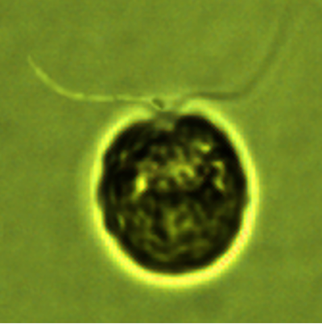
Phylum: Chlorophyta
Class: Chlorophyceae
Order: Volvocales

Habitat: plankton
Distinctive features: small bi-flagellated single cells with cup-shaped chloroplast.
Organization: flagellated single cells
Color: green
Cell shape: spherical
Cell diameter (D): 7 – 13 μm, median: 10 μm (N=562).
Cell biovolume: 200 – 1300 μm³, median: 520 μm³.
Biovolume equation: Sphere V, μm³ = 4/3 π (D/2)³.

Morphological features:
Spherical flagellated green single cells, with two flagella about same length as cell and a cup-shaped chloroplast. Several hundreds of species of Chlamydomonas were described, they are difficult to distinguish by light microscopy, we did not identify the Kinneret Chlamydomonas to species level, and it is possible that there is more than one species.

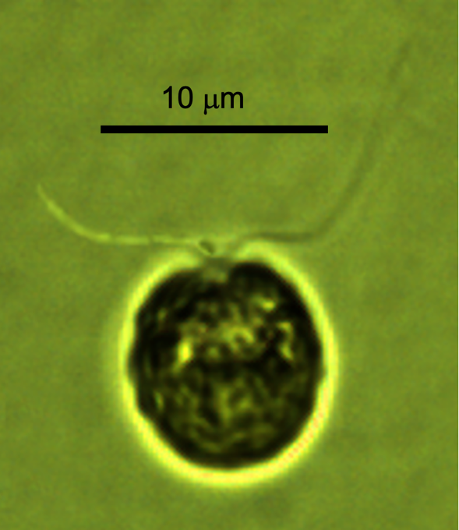
Plate 1. Chlamydomonas sp. from Lake Kinneret (not identified to species level). Photo by Alla Alster.

Ecology: Abundance data for this taxon was heavily biased by the person counting it: Analyst 4 (1983 – 1995) counted more Chlamydomonas individuals in her samples than the two other analysts and Analyst 5 counted the least (Fig. 1). This “analyst effect”, dominant to other pattern in the cell abundance data, is a big limitation of long-term phytoplankton data sets based on microscope counts, it is not unique to Lake Kinneret. The discrepancies between analysts exist for all species, but at varying levels, depending on the taxon being counted: species that are easier to misidentify are more susceptible. For the annual cycle (Fig. 2) we present only data counted by Technician 3. It shows Chlamydomonas spp. are present in the water at all times of the year, with a tendency to higher abundance from October till February. Cell size remains close to constant over time, with no apparent annual pattern.

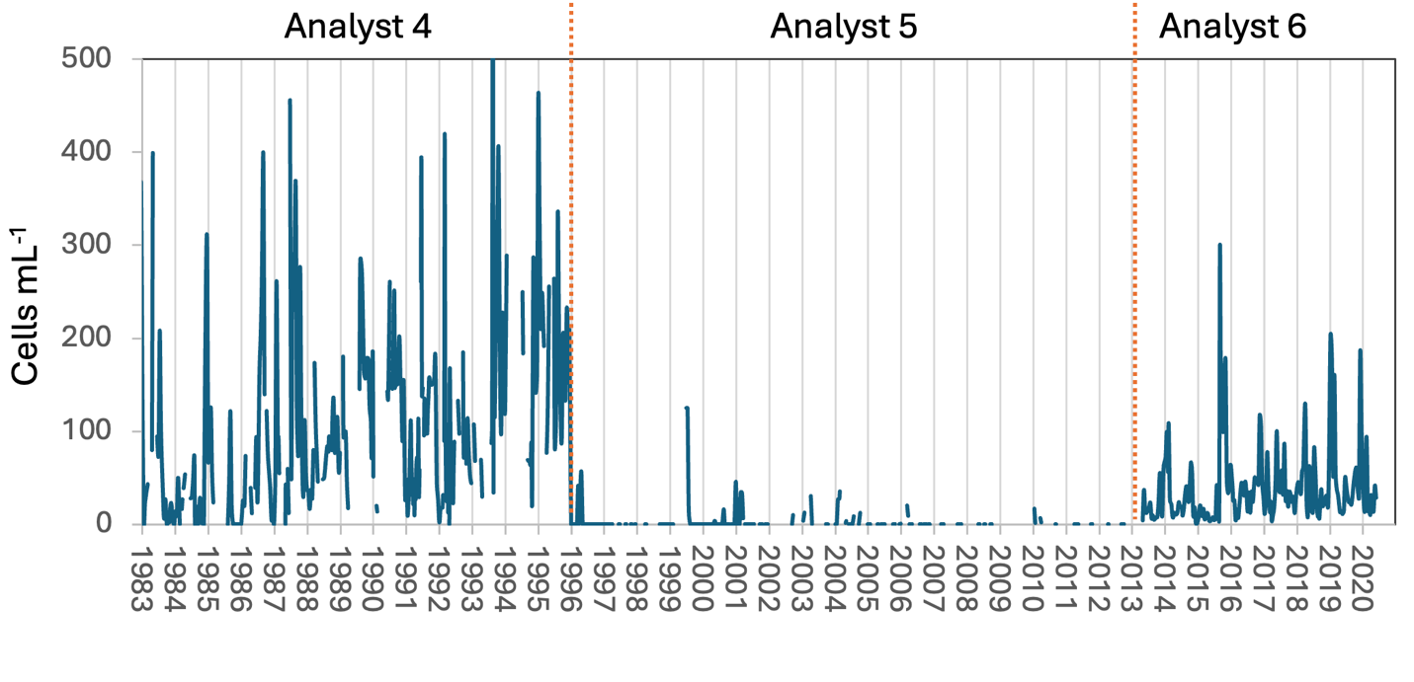
Figure 1. Time series of mean epilimnion cell abundance of Chlamydomonas sp. in Lake Kinneret, 1983-2020. A analyst effect is apparent in the data.

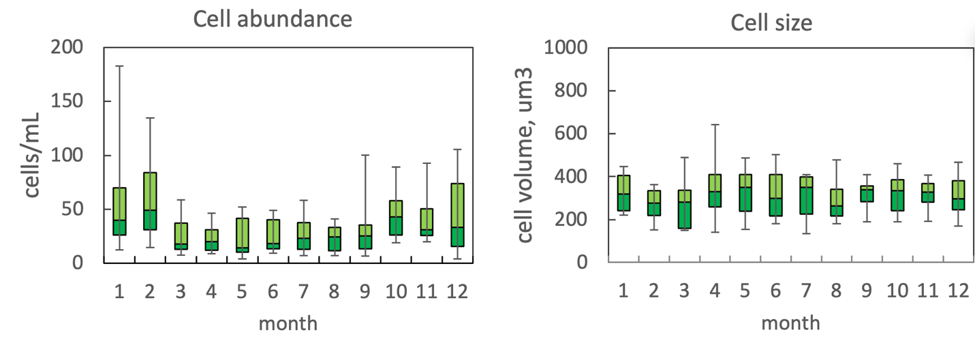
Figure 2. The annual pattern of water column cell abundance (left) and volume per cell (right) of Chlamydomonas in Lake Kinneret, based on data for 2013-2020 (=Analyst 6 of Fig. 1). Statistics shown are median – middle line; 25th to 75th percentiles – box content; 90th and 10th percentiles - top and bottom bars, respectively.

Environmental conditions:
The Kinneret data for Chlamydomonas for 2013-2020 (Analyst 6) do not show distinct correlations with any of the environmental factors we examined: it seems indifferent to water temperature, mixed layer depth, euphotic depth, Secchi depth, chloride, nutrients (not shown). A possible reason is that probably several species of Chlamydomonas are aggregated in our dataset.

Cite this record as:
Tamar Zohary, Alla Alster. [Date when Item was last updated]. Electronic publication. Israel Oceanographic & Limnological Research. [Date when last accessed].

Further reading:
Kaplan-Levy RN, Alster-Gloukhovski A, Benyamini Y, Zohary T. 2016. Lake Kinneret phytoplankton: integrating classical and molecular taxonomy. Hydrobiologia 764(1):283-302.

Eudorina elegans Ehrenberg 1832

Phylum: Chlorophyta
Class: Chlorophyceae
Order: Volvocales

Habitat: plankton
Distinctive features: flagellated colonies, cells more or less evenly distributed within a common spherical envelope
Organization: flagellated coenobia
Color: green
Cell shape: spherical
Colony shape: spherical to ellipsoidal
Cell diameter (D): 4 – 10 μm, median: 6 μm (N=54).
Cell biovolume: 25 – 460 μm³, median: 100 μm³.
Biovolume equation: Sphere V, μm³ = 4/3 π (D/2)³
Colony diameter: 40-150 μm
Cells per colony: 4-16

Morphological features:
Eudorina elegans coenobia in Lake Kinneret are spherical or ellipsoidal, 60-200 μm in diameter, with 4 to 16 cells per colony. Individual cells are spherical or slightly pear-shaped, regularly arranged at periphery of a mucilaginous envelope. With cup-shaped chloroplast and up to 5 pyrenoids per cell, anterior eyespot, two contractile apical vacuoles. The two equal-length flagella are longer than the cell. They protrude through the mucilaginous envelope and enable movement of the colony as a single unit.

Plate 1. Eudorina elegans from Lake Kinneret. Photo by Alla Alster.

Ecology:
Eudorina elegans is rare in our Kinneret samples, in 50 years of monitoring the species was counted <20 times, most of them since 2013 (Fig. 1).
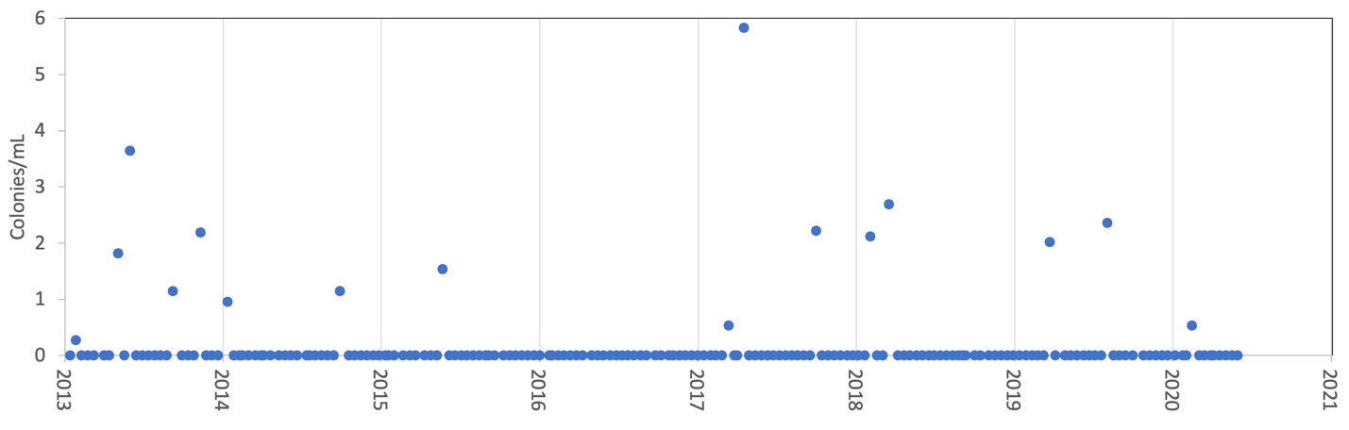
Figure 1. Time series of the mean abundance of Eudorina elegans colonies in Lake Kinneret epilimnion, 2013-2020.

Environmental conditions:
The few times when Eudorina elegans was counted occurred at the full range of temperature, NO₃ and NH₄, when chlorophyll was < 500 mg m⁻², chloride > 230 mg L⁻¹, Z_{eu} ranged 6-11 m, Secchi depth ranged 2-4 m, alkalinity was > 100 mg CaCO₃ L⁻¹, Ca > 44 mg L⁻¹, DON < 0.5 mg L⁻¹ and TDP < 100 μg L⁻¹

Cite this record as:
Tamar Zohary, Alla Alster. [Date when Item was last updated]. Electronic publication. Israel Oceanographic & Limnological Research. [Date when last accessed].

Pandorina morum (O. Müller) Bory 1826

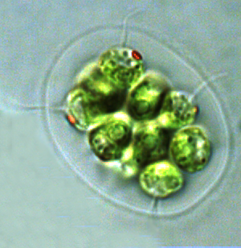

Phylum: Chlorophyta
Class: Chlorophyceae
Order: Volvocales

Habitat: plankton - littoral
Distinctive features: flagellated colonies of densely-packed cells, often with eyespots
Organization: flagellated coenobia
Color: green
Cell shape: spherical
Colony shape: subspherical
Cell diameter (D): 8 – 17 μm
Cell biovolume: 40 – 400 μm³
Biovolume equation: Sphere V, μm³ = 4/3 π (D/2)³.
Colony diameter: 20-60 μm
Cells per colony: 8-16

Morphological features:
The coenobia are made of 8 or 16 cells compressed into a dense spherical aggregate that is surrounded by an envelope of hyaline mucilage. Each cell has two equal-length flagella that are longer than the cell. With a cup-shaped chloroplast, 1 or more pyrenoids, 2 contractile vacuoles an anterior red eyespot.

Plate 1. A flagellated coenobium of Pandorina morum from the littoral of Lake Kinneret. Red eyespots are seen on three cells, flagella on four. Photo by Alla Alster.

Ecology: Pandorina morum is common in the littoral zone of Lake Kinneret, but practically never seen in the pelagic water. Hence there are no ecological data for it. The species is common in stratified shallow lakes rich in nitrate. The specimen in Plate 1 was collected at the shore by the Kinneret Limnological Institute in March 2006.

Cite this record as:
Tamar Zohary, Alla Alster. [Date when Item was last updated]. Electronic publication. Israel Oceanographic & Limnological Research. [Date when last accessed].

Further reading:
Kaplan-Levy RN, Alster-Gloukhovski A, Benyamini Y, Zohary T. 2016. Lake Kinneret phytoplankton: integrating classical and molecular taxonomy. Hydrobiologia 764(1):283-302.

